CMP4271

# Task: Digital to Physical.

## 8.1 Game Premise

The game the team chose was a game called Tetris. A popular strategic game which relies on people to move differently shaped pieces which descend onto a playing field. The players fill in missing spaces on the board which allows them to create lines.

## 8.2 Rules and Mechanics

The rules for the physical Tetris game include:

* Players may only hold a piece per turn.

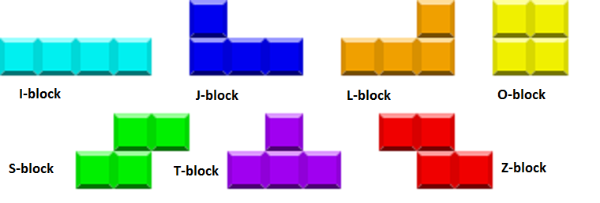

Figure 1. The Tetris pieces. This figure shows the different shapes of the Tetris pieces.

* Players are not allowed to switch their given piece for pieces they like.
* Players must prevent blocks from over stacking.
* Players lose if they over-stack.

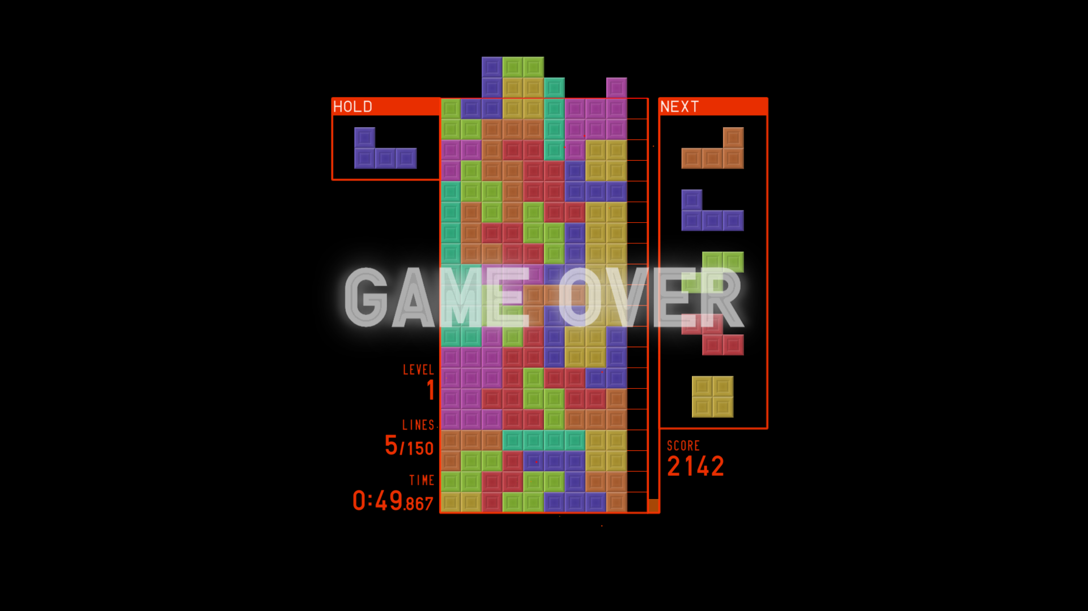

Figure 2. Over-stacking. This figure shows over-stacking in Tetris

* Only two players can play at a time.

The game’s mechanics are about the same as the original digital version and the mechanics for the physical version include:

* A spinning wheel will determine what piece the player can use next.
* When a player eliminates 4 lines, it is called a “Tetris”.
* Players drop the Tetris block at their desired location with each turn.
* If a Tetris is completed, the blocks are pushed out from the side of the board to make room for more blocks.
* The Tetris blocks can be rotated to a different position before dropping.

## 8.3 Gameplay

The goal of Tetris is to get more Tetrises, i.e., the points gotten from eliminating 4 rows of blocks, than your opponent in a set time to win.



Figure 3. The Game board. This figure shows what the game board is supposed to look like.

* The first player spins a wheel to determine the shape they use at their turn.
* The player can then rotate the shape to any position they wish.
* The player picks a location from the top of the game board to drop the shape.
* If a player gets a Tetris during the course of game play, the four rows are pushed out from the side of the gameboard and the player is awarded points.
* If a player over-stacks the gameboard and causes the blocks to spill out, then the player loses.
* Game continues until a player over-stacks or the time is elapsed and the player with the highest points wins.

## 8.4 Play Testing

During the play testing stage, the team performed internal play testing and decided that the side of the board should have spaces for pushing out the blocks when a Tetris is achieved. Another result of play testing was how to decide which block a player could use during their turn, the solution to this problem was to use a spinning wheel.

## 8.5 Experience

The team had put out a list of games to select from and ended up choosing the game Tetris. Steve Yap took over the delegation of jobs and the creation of the slides. The team worked together considerably well, checking on each other’s slides to make sure that information was accurate and did not contradict what was already included.

## 8.6 Reflection

During the session, I was unable to contribute much to the team, due to internet connection issues, but I was able to edit and make a few additions to the slides. In future sessions, I would like to do more research for the given task.

## 8.7 Members of the team

The members of the team include: (Steve) Yap Hou Yen, Ngozi Egonu, Jack Collins and Danyal Mahmood.